***algo_launcher deploy procedure***

***1.***As shown in Figure 1 below



figure 1

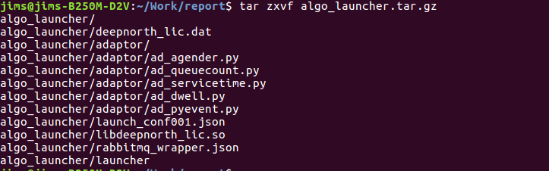***2.***Decompression the algo_launcher.tar.gz shown in Figure 2 below

Figure 2

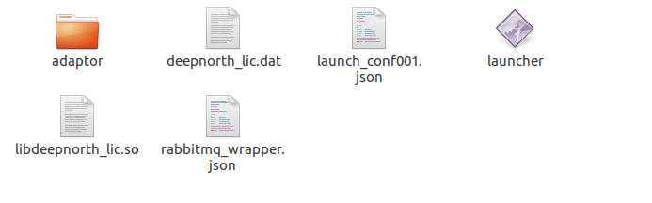3.Open the algo_launcher folder shown in Figure 3 below

Figure 3

4.Open rabbitmq_wrapper.json and modefy the mq_host paramater.mq_host is mean to rabbitmq server ip .shown in Figure 4 below

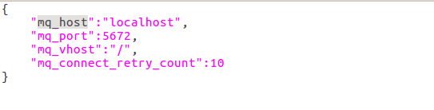

Figure 4

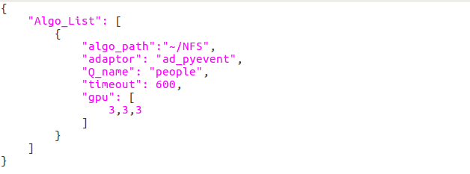5.Open launch_confxxx.json and set paramaters or add an another launch_confxxx.json for example launch_conf001.json and launch_conf002.json and so on.The format requirements are shown in Figure 5 below

Figure 5

algo_path: is mean to set Local_Farm folder path.

adaptor: is mean to set algorithm name

Q_name: is mean to set rabbitmq queue name

timeout: is mean to set algorithm runing the maximum permissible time

gpu: is mean to set the number of processes on each card

etcd_url: is mean the algo woker add etcd registe function,if this key was added.(default don’t set the key)

sql_model:if set this key value is “sql” it’s mean the algo woker will execute sql launger for results.

Default algo woker execute write json file and don’t set this key.

6.run launcher shown in Figure 6 below

(1)./launcher -h

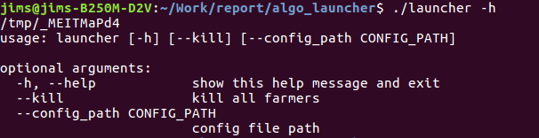 this command is mean to view launcher about methods of use.shown in Figure 7 below

Figure 7

(2)./launcher --config_path launch_confxxx.json

this command is mean to start the project and use the

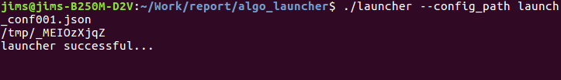launch_confxxx.json file .shown in Figure 8 below

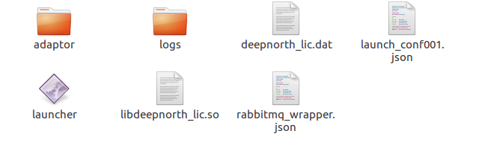Figure 8

when the project start successful ,the terminal will show “launcher successful” and the local path will generate a new folder and it’s name is “logs”

(3)./launcher –-kill shown in Figure 9 below.

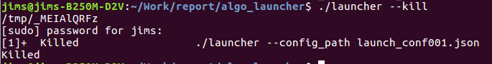

Figure 8

when you start the priject again,you must run “./launcher –kill”command in order to close the process before